Assessment Question: - Using the graph (below right), describe the pattern of sunspot activity between 1960 and 2010.
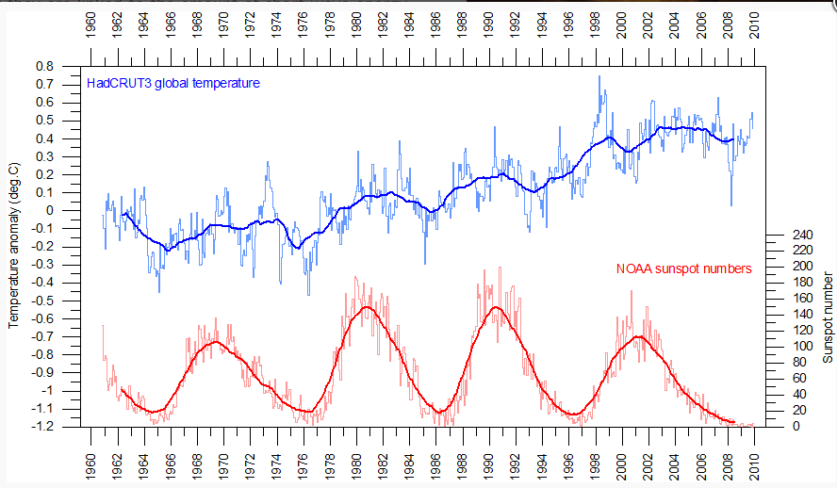
[5 marks]

_______________________________________________________________________________________________________________________________________________________________________________________________________________________________________________________________________________________________________________________________________________________________________________________________________________________________________________________________________________________________________________

